# EE40 Final Project Proposal

Authors: Austen Satterlee, Tarun Chaudhry

## Description

Our robot will be a self-balancing robot that stands on the back two wheels. It will incorporate adding a digital gyroscope/accelerometer, along with a state estimator and digital state PID control system to keep the robot in balance. Additionally, we will incorporate a bluetooth control system to drive and control the robot’s systems. Since the robot will have wheels instead of springs to move, we will incorporate the following 2 analog circuits: an H-bridge circuit with a switch to drive the motors backward and forward, and an analog low pass for the output of the accelerometer.

## Circuit Schematic

Motor H-Bridge (IO1 is angular velocity of the shaft when there is no load)

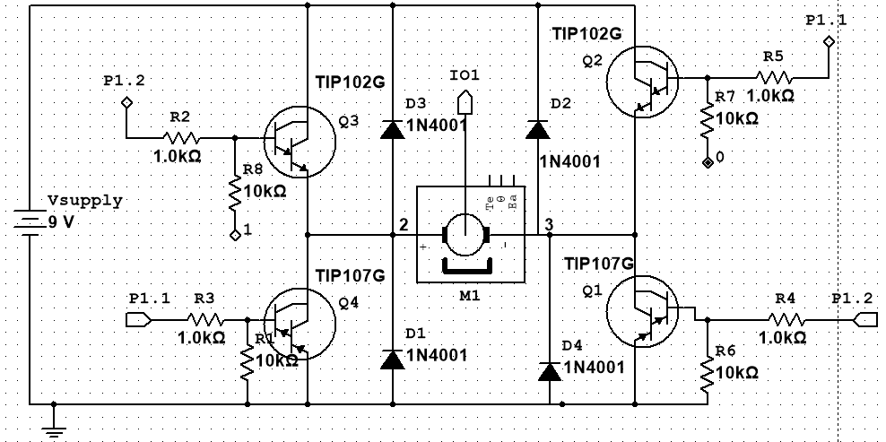

### Parts list

|  |  |  |
| --- | --- | --- |
| Part | Link | Price ($) |
| Wheels | <http://www.robotshop.com/en/pololu-wheel-90-10mm-black-pair.html> (or similar depending on motor) | $9.95 |
| Bluetooth Chipset/Receiver | http://www.robotshop.com/en/electronic-brick-serial-bluetooth-module.html | $12.60 |
| Digital gyroscope/Analog Accelerometer | MPU6050 (gyro) - http://amzn.com/B008BOPN40  ADXL335 (accel) - http://amzn.com/B00FIJG5I4 | $7.67 |
| 2x TIP-102 NPN | https://www.fairchildsemi.com/datasheets/TI/TIP102.pdf | $0.00 |
| 2x TIP-107 PNP | https://www.fairchildsemi.com/datasheets/TI/TIP105.pdf | $0.00 |
| TOTAL |  | $30.22 |

## Flow Charts

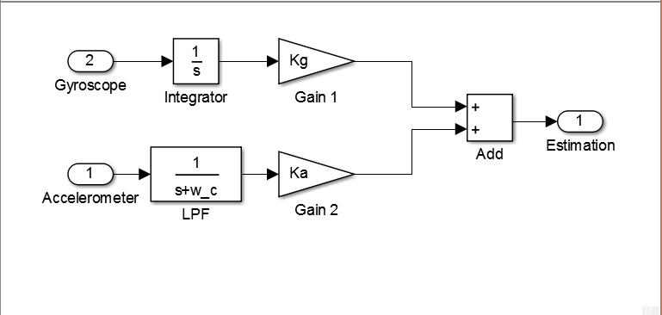

Figure : State estimation flow chart

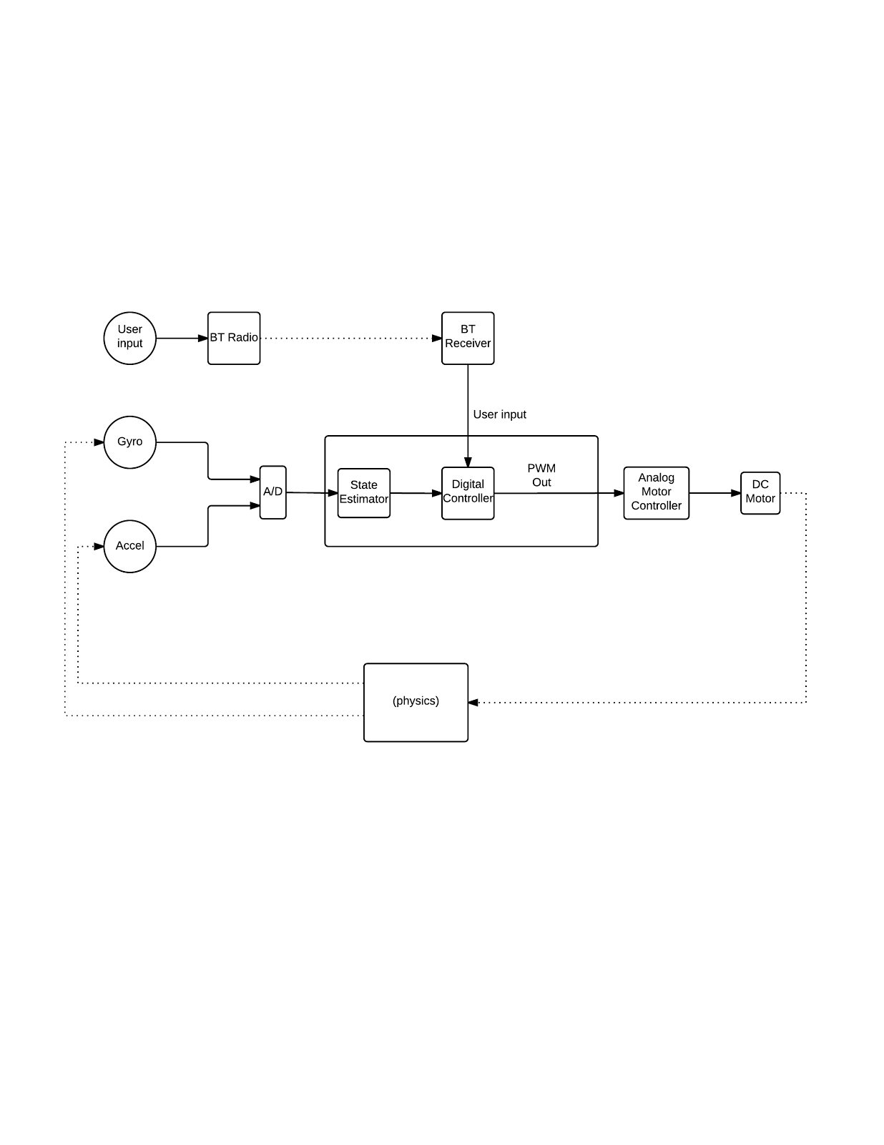

Figure : System structure flow chart